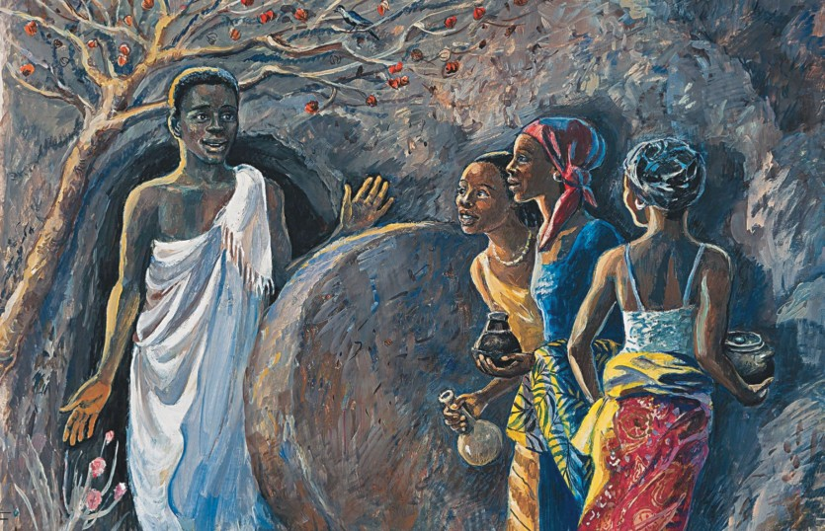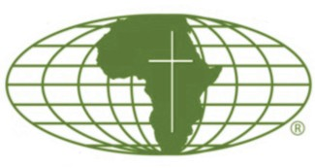

**Since 1868… 150 years and counting**

**MISSIONARIES OF AFRICA**

**No. 1, 2021**

***Help us continue our mission in Africa!***

**The Africa Report**

Charitable IRA Rollover

What is a Charitable IRA Rollover?

* Charitable IRA Rollover is a permanent provision in the U.S. tax code for donors age 70½ or older to make a tax-wise gift to non-profit organizations such as the Missionaries of Africa.

**Day of the Resurrection, Artist Unknown**

* Join our Friends of Hope monthly giving plan.
* Memorial Gifts in memory of a loved one.
* Celebrate a birthday, wedding or anniversary with a donation to our works in Africa.
* Donations of stock, appreciated securities, bonds or annuities provide the same benefit as a cash gift.
* Life Insurance: consider naming the Missionaries of Africa as a beneficiary.

Benefits of Charitable IRA Rollovers

* Satisfies requirements for annual minimum IRA withdrawals.
* Avoids federal and in some cases, state income tax.*
* Provides vital and ongoing support to the Missionaries and their missions in Africa.

Guidelines

* Donors age 70 ½ or older at the time of distribution.
* Gifts must be transferred directly from your IRA account to the Missionaries of Africa.
* Charitable gifts up to $100,000 can be given each year.

How to make a Charitable Gift?

* Donors should contact their IRA Bank or broker/administrator to request an IRA distribution transfer to the Missionaries of Africa. Instruct your administrator to issue a check to

**“Do not be amazed! You seek Jesus of Nazareth, the crucified. He has been raised; he is not here.*”***

**Mark 16:6**

for hope that the global pandemic's progression will be contained in time and space to the delight of us all. We all look forward to resuming our daily activities and living a normal life.

Even in these unprecedented times of anxiety and uncertainty, we should not give in to the temptation of sadness and exclusion. On the contrary, let us keep in mind Pope Francis' message in which he called for generosity and support, particularly towards those experiencing unemployment, poverty, and toward domestic violence.

I take this opportunity to express my gratitude for your continuous support that enables us to lead peace-building programs in Nigeria, to improve healthcare services in Malawi and Uganda, and to provide clean water to communities in Kenya and Tanzania.

* Bequests: an estate gift to the Missionaries of Africa will continue our mission works.

Society of Missionaries of Africa, Inc.

Development Office 1622 21st. Street, NW

Washington, DC 20009-1003

Dear Friends,

The British poet, Edith Nesbit, in

*The Promise of Spring,* describes in colorful terms Springtime as the ideal season of rebirth and renewal:

** Any questions, please call our Development Office ** 1-877-523-4662

* The Charitable IRA Rollover is a federal law.

Consult your tax preparer for your state regulations.

The Africa Report is published four times a year by the

Society of

Missionaries of Africa, Inc.

***O Spring, darling Spring,***

***O sweet days of blue weather The thrushes shall sing***

***Fields shall grow green again.***

This is true for most of us. Every *spring*, we experience new life when nature displays the best of its beauty. And it is particularly heartening after the woeful year 2020 that affected all of us in one way or the other. As the vaccination campaign rolls out and with an increasing number of people being inoculated against the COVID-19 virus, there is room

Protecting Your Privacy

The Missionaries of Africa do not sell, rent, or exchange donors’ names nor donors’ contact information.

We are very grateful to you and cherish your commitment to our mission and service among the people of Africa.

1622 21 Street, NW

st

Washington, DC 20009-1003

(202) 232-5995

Series 12, Vol. 94

No. 1, 2021

Rev. Barthelemy Bazemo, M.Afr. President

[**www.missionariesofafrica.org**](http://www.missionariesofafrica.org/)

[**www.missionariesofafrica.org**](http://www.missionariesofafrica.org/)

**Know more about us / Contact us / Donate on line**

**Know more about us / Contact us / Donate on line**

***The Promise of New Life!***

Support our mission when you shop at Amazon! Simply pick the Missionaries of Africa as your charitable organization and Amazon will give .05% of your eligible purchase. amazon.smile.com

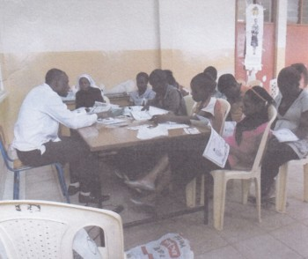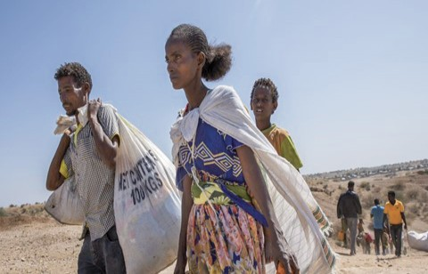

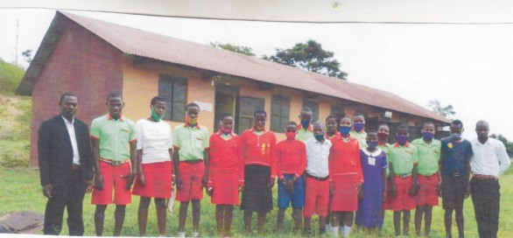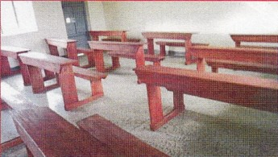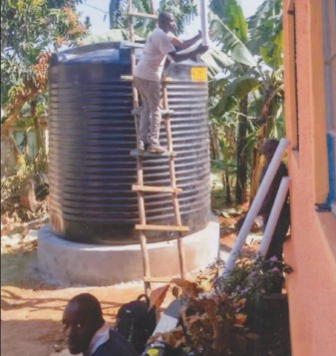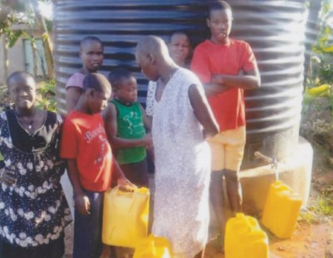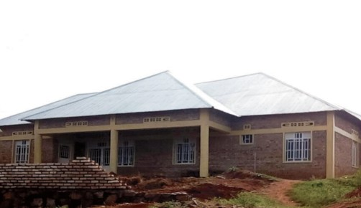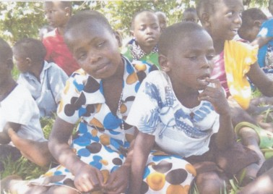

Thanks to your financial support ...

**ABOVE LEFT: FAMILIES LINE UP FOR FRESH WATER. RIGHT: A WORKER MAKES THE FINAL CONNECTION TO THE WATER TANK!**

Because of your kindness and generosity ...

**Photos courtesy of Fr. Aloysius Maniragaba**

[**www.missionariesofafrica.org**](http://www.missionariesofafrica.org/)

[**www.missionariesofafrica.org**](http://www.missionariesofafrica.org/)

**Know more about us / Contact us / Donate on line**

**Know more about us / Contact us / Donate on line**

**Teachers and students outside of their class- room. Desks made by local craftsmen!**

Thanks to your financial support, the students at St. Anthony Primary School in Kamwenge, Uganda, have received 50 new school desks!

"The desks could not have come at a better time," writes Fr. Aloysius Maniragaba, pastor of the mission in the village of Bisozi. "The people in the village worked together and built 10 classrooms but the students had nowhere to sit. **Thanks to your generosity**, we were able to purchase the materials for local craftsmen to construct new desks for the children. What a difference this is making in the education of our boys and girls. God bless you!”

**Fr. Aloysius Maniragaba**

**Pastor**

Bisozi, Uganda

NEW DESKS FOR STUDENTS AT ST. ANTHONY PRIMARY SCHOOL!

Kigali, Rwanda

New Shelter for Homeless and Orphans!

"The plight of the poor is beyond description," explained Fr. Simplice Traore, a Missionary of Africa priest working in Kigali, Rwanda. "Children here who have lost their parents to illness often have no one to take care of them and

nowhere to turn. A group of religious sisters here had

received a grant to build a shelter for homeless and orphaned children -- but there wasn't enough money to complete the project. Thanks to the generosity of the Missionaries of Africa, the shelter is now complete and providing food and a home to those who had no place to go."

"Please convey to our benefactors the good that they are doing whenever they support such efforts as this! Thank you again."

**Fr. Simplice Traore, M.Afr.**

**Pastor**

**(Photos provided by Fr. Simplice Traore)**

**Top: A new home for the poor and orphans; Bottom: A few of the children currently being cared for at the shelter.**

Kasese, Uganda

Water for School and Clinic!

"Imagine the difficulties of trying to teach small children who are thirsty

-- or caring for those who are sick . . . but not having a supply of clean water. Living without a source of clean water was one of the biggest hurdles to our work," writes Fr. Godwine Bwambale, a priest working in the village of Kasese in the western region of Uganda.

"One of the local residents had donated a piece of land for us to use in building a water harvesting system. The local tradesmen were also willing to do all of the manual work that was needed. But we still did not have enough money to buy the building supplies."

"Thanks to your generosity, we were able to purchase all of the building materials, including lumber, concrete blocks, cement, pipes, valves, water storage tanks -- everything. Now we have water for our more than 1500 students and for the patients in our clinic.

What a difference you have made in the lives of everyone here."

**Fr. Godwine Bwambale**

**Pastor**

**(Photos provided by Fr. Godwine Bwambale)**



**Refugees fleeing the violence in Tigray, Ethiopia**

Fighting Human Trafficking in East Africa!

Society of the Missionaries of Africa Washington, DC 20009-1003

Dear Friends:

Because of your financial support, we have been able to expand our work of combatting human trafficking! Over the past year, we have been able to help young women in Nairobi, Kenya (especially in the Mukuru Slums), and in neighboring Tanzania. We have also been successful in training 100 additional adults who are now working to counsel young women who have been victims of human trafficking. Thank you for all you do!

**Sr. Mary O'Malley, MMM Project Coordinator**

**Small group session of individuals being trained to help victims of human trafficking.**

**Photos provided by Sr. Mary O'Malley, MMM**

**Emergency Humanitarian Crisis!**

An urgent humanitarian crisis continues to grip the people of Tigray Region in northern Ethiopia. While no one is saying how many people have died thus far, it appears that the number of innocent men, women, and children who have been killed is in the thousands. "Many bodies have yet to be buried," writes Fr. Bonaventure Bwanakweri, M.Afr., leader of the Missionaries of Africa serving in Ethiopia. "Survivors are struggling to get food, and many are dying because of hunger. Particularly vulnerable are children, the elderly, and pregnant or nursing mothers. We need emergency assistance in whatever way you can help."